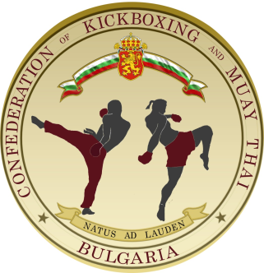
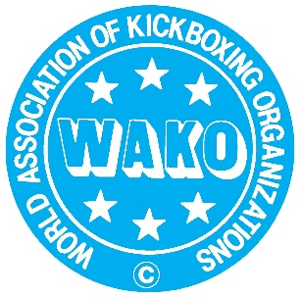
WAKO REFEREE ACADEMY 2019 - BANSKO, BULGARIA

APPLICATION FORM TATAMI&RING REFEREES

Hereby we NATIONAL FEDERATION NAME would like to confirm that following referees from our federation will participate in the WAKO REFEREE ACADEMY BULGARIA 2019 :

Nu. | Name/Surname | Male/ female | Styles : TATAMI/RING | Intenational Grade | National Grade | Travel plan ( by car or plane, if plane flight numbers and dates) | Contact e-mail & mobile phone
1
2
3
4
5
6
7
8
9
10
11
NATIONAL FEDERATION NAME
Responsible person – name, surname, position, e-mail, contact phone
Participation fee : 195eur per person
In favour of : Bulgarian Confederation of Kickbox and Muay Thai
With Central Cooperative Bank AD, 87 Tsarigradsko Shoes BBlvd, 1086 Sofia, Bugaria
IBAN : BG90 CECB 9790 1498 9707 00
BIC : CECBBGSF

Contacts for information and registration :
Denitsa Milenkova – WAKO Bulgaria event manager , mob. +359888744700
Ivan Georgiev - WAKO Bulgaria event manager , mob. +359888770203
e-mail : wakorefereeacademy2019@yahoo.com

