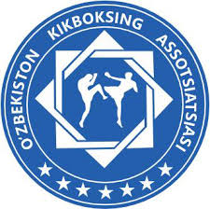 | Oʻzbekiston Kikboksing Assotsiatsiyasi  WAKO Uzbekistan  WAKO Uzbekistan World Cup 2024

Appendix A) - Hotel Reservation Form
Please return this form by e-mail to:
Mr. Boykuziev Odil
Email: uzbka@inbox.ru
Tel. +99897 7333716 (phone, whatsapp, telegram)
Federation / Club / Individual:
Country:
Address:
Phone: |  |  |  |  |  |  | Fax:
E-mail:
Tick | Name |  | Room type | Arrival date |  | Departure date |  | Number Rooms | Number Persons | Num. Nights | Per night | Total amount
 | Hotel  4 stars**** |  | Single |  |  |  |  |  |  |  | € 90,00
 |  |  | Double |  |  |  |  |  |  |  | € 70,00
 |  |  | Triple |  |  |  |  |  |  |  | € 65,00
 |  |  |  |  |  |  |  |  |  |  | TOTAL

________________ ___________________________
Date and place Stamp and Signature

